|  |
| --- |
| O-RAN.WG10.TE&IV-R003-v01.00 |
|  |

|  |  |
| --- | --- |
| Technical Specification | |
| |  | | --- | | O-RAN Work Group 10  Topology Exposure and Inventory Management Services  Use Cases and Requirement Specification | | |
| O-RAN Work Group 10 Topology Exposure and Inventory Management Services Use Cases and Requirement Specification |
|  |

Copyright © 2023 by the O-RAN ALLIANCE e.V.

The copying or incorporation into any other work of part or all of the material available in this specification in any form without the prior written permission of O-RAN ALLIANCE e.V. is prohibited, save that you may print or download extracts of the material of this specification for your personal use, or copy the material of this specification for the purpose of sending to individual third parties for their information provided that you acknowledge O-RAN ALLIANCE as the source of the material and that you inform the third party that these conditions apply to them and that they must comply with them.

O-RAN ALLIANCE e.V., Buschkauler Weg 27, 53347 Alfter, Germany

Register of Associations, Bonn VR 11238, VAT ID DE321720189

Contents

Foreword 3

Modal verbs terminology 3

1 Scope 3

2 References 3

2.1 Normative references 3

2.2 Informative references 4

3 Definition of terms, symbols and abbreviations 4

3.1 Terms 4

3.2 Symbols 4

3.3 Abbreviations 4

4 Use Case Description 5

4.1 Analysis of Existing O-RAN Use Cases 5

4.1.1 Use case 1: O-RAN network provisioning 5

4.1.1.1 Background and goal of the use case 5

4.1.1.2 Entities/resource involved in the use case 5

4.1.1.3 Solutions 5

4.1.1.4 Required Data 10

4.1.2 Use case 2: Alarm query with TE&IV services 10

4.1.2.1 Background and goal of the use case 10

4.1.2.2 Entities/resources involved in the use case 11

4.1.2.3 Solutions 12

4.1.2.4 Required data 13

4.2 New Topology and Inventory Use Cases 13

4.2.1 Use case 1: Topology based alarm correlation 13

4.2.1.1 Background and goal of the use case 14

4.2.1.2 Entities/resource involved in the use case 14

4.2.1.3 Solutions 14

4.2.1.4 Required data 17

4.2.2 Use case 2: O-RAN Network Planning 17

4.2.2.1 Background and goal of the use case 17

4.2.2.2 Entities/resource involved in the use case 18

4.2.2.3 Solutions 18

4.2.2.4 Required Data 22

5. Requirements 23

5.1 Functional Requirements 23

5.2 Non-Functional Requirements 24

Change History 25

# Foreword

This Technical Specification (TS) has been produced by WG10 of the O-RAN Alliance.

# Modal verbs terminology

In the present document "**shall**", "**shall not**", "**should**", "**should not**", "**may**", "**need not**", "**will**", "**will not**", "**can**" and "**cannot**" are to be interpreted as described in clause 3.2 of the O-RAN Drafting Rules (Verbal forms for the expression of provisions).

"**must**" and "**must not**" are **NOT** allowed in O-RAN deliverables except when used in direct citation.

# 1 Scope

The content of the present document is subject to continuing work within O-RAN and may change following formal O-RAN approval. Should the O-RAN Alliance modify the contents of the present document, it will be re-released by O-RAN with an identifying change of version date and an increase in version number as follows:

version xx.yy.zz

where:

xx: the first digit-group is incremented for all changes of substance, i.e. technical enhancements, corrections, updates, etc. (the initial approved document will have xx=01). Always 2 digits with leading zero if needed.

yy: the second digit-group is incremented when editorial only changes have been incorporated in the document. Always 2 digits with leading zero if needed.

zz: the third digit-group included only in working versions of the document indicating incremental changes during the editing process. External versions never include the third digit-group. Always 2 digits with leading zero if needed.

The present document specifies new use cases and refines existing use cases present in O-RAN specifications for Topology Exposure and Inventory Management. For each use case, the document describes the motivation, resources, steps involved and the data requirements. The functional and non functional requirements for Topology Exposure and Inventory Management services are derived from the use cases that further serve as a basis for specifying the topology and inventory models, services and APIs.

# 2 References

## 2.1 Normative references

References are either specific (identified by date of publication and/or edition number or version number) or non‑specific. For specific references, only the cited version applies. For non-specific references, the latest version of the referenced document (including any amendments) applies.

NOTE: While any hyperlinks included in this clause were valid at the time of publication, O-RAN cannot guarantee their long-term validity.

The following referenced documents are necessary for the application of the present document.

[1] 3GPP TS 23.032: “3rd Generation Partnership Project; Technical Specification Group Services and System Aspects; Universal Geographical Area Description (GAD) (Release 17)”

## 2.2 Informative references

References are either specific (identified by date of publication and/or edition number or version number) or non‑specific. For specific references, only the cited version applies. For non-specific references, the latest version of the referenced document (including any amendments) applies.

NOTE: While any hyperlinks included in this clause were valid at the time of publication, O-RAN cannot guarantee their long-term validity.

The following referenced documents are not necessary for the application of the present document, but they assist the user with regard to a particular subject area.

[i.1] 3GPP TR 21.905: “Vocabulary for 3GPP Specifications”

[i.2] O-RAN-WG10.OAM-Architecture-v07.00: “O-RAN Operations and Maintenance Architecture v07.00”

[i.3] 3GPP TS 28.541: “5G Network Resource Model (NRM); Stage 2 and Stage 3 (Release 18)”

[i.4] O-RAN.WG6.O2-GA&P-R003-v03.00:"O2 Interface General Aspects and Principles"

[i.5] O-RAN.WG6.O2IMS-INTERFACE-v03.00: “O2ims Interface Specification”

[i.6] O-RAN.WG2.R1UCR-R003-v03.00: “R1interface: Use Cases and Requirements”

# 3 Definition of terms, symbols and abbreviations

## 3.1 Terms

For the purposes of the present document, the terms given in [i.1] and the following apply:

**Inventory**: Inventory consists of information about planned, active and available networks, resources, services, their states, relationships and specific properties.

**Topology**: Topology consists of information about relationships and characteristics of services and resources, derived from inventory and from other SMO services.

**RAN Resources**: RAN resources includes GNBDUFunction, GNBCUCPFunction, GNBCUUPFunction, NRCellCU, NRCellDU, NRSectorCarrier, NRCellRelation, NRFreqRelation, NRFrequency etc., as depicted in 3GPP 5G NRM [i.3]

**NF Deployment**: Based on term usage in [i.4], NF Deployment covers O-DU, O-CU-UP, O-CU-CP, near-RT RIC deployments in the O-Cloud

**O-Cloud Resources**: O-Cloud Resources include O-Cloud IMS model elements as depicted in the O-RAN IMS Interface [i.5]

**TE&IV resources**: TE&IV resources depict RAN resources, O-Cloud resources, and relationships with other RAN or O-Cloud resources etc., represented in topology and inventory models.

**Planned inventory**: Represents the physical, logical and virtual resources, their state, specific properties and relationships, reserved for planned network realization.

## 3.2 Symbols

Void

## 3.3 Abbreviations

TE&IV: Topology Exposure and InVentory management

# 4 Use Case Description

## 4.1 Analysis of Existing O-RAN Use Cases

## 4.1.1 Use case 1: O-RAN network provisioning

### 4.1.1.1 Background and goal of the use case

The O-RAN Provisioning use case in WG10 OAM Architecture Specification [i.2] describes the sequence of steps to deploy and provision O-RAN NFs on physical/virtualized resources by leveraging the SMO Framework and O-Cloud management entities.

The goal of this use case is to highlight the role of Topology Exposure (TE) and Inventory Management (IV) services during provisioning of O-RAN NFs. This use case leverages the OAM flows of O-RAN provisioning use case and highlights the interactions of O-RAN entities with TE & IV service producer. These interactions are for CRUD operations on inventory objects corresponding to the newly deployed NFs.

### 4.1.1.2 Entities/resource involved in the use case

The SMO Framework leverages TE &IV services within the SMO. TE&IV services maintain the state of O-RAN NFs in the inventory, which will be used by SMO to derive the contextual information of the network. TE&IV services support CRUD operations on inventory objects and interactions with OAM functions.

### 4.1.1.3 Solutions

Table 4.1.1.3-1: O-RAN network provisioning

| **Use Case Stage** | **Evolution / Specification** | **<<Uses>>**  **Related use** |
| --- | --- | --- |
| Goal | O-RAN network provisioning using TE & IV services |  |
| Actors and Roles | 1. Service Management and Orchestration Framework: NFO, TE & IV service producer, OAM Functions, Non-RT RIC 2. O-Cloud: DMS 3. PNF 4. VNF |  |
| Assumptions | Common Topology and Inventory Model is available in TE & IV service producer |  |
| Pre-conditions | 1. The Service Management and Orchestration Framework and O-Cloud are connected and interact normally 2. O-Cloud supports platform and resource management normally 3. The PNF is constructed/installed and ready to be activated 4. The VNF Software Package has been uploaded to the O-Cloud 5. Secure network connectivity is already available between RAN components 6. O-DU and O-RU are PNFs, available in the inventory with planned status and ready to be activated 7. On boarding of VNF Descriptors to the O-Cloud is completed |  |
| Begins when | The network operator/manager decides to deploy an O-RAN network in specific geo-location e.g. location identified using TE&IV Services |  |
| Step 1 (M) | The radio planner orders RAN Service Deployment |  |
| Step 2 (M) | The SMO initiates the O-RAN Service instantiation |  |
| Step 3.1 (O) | The SMO creates placeholder object for O-RAN Service in the inventory |  |
| Step 3.2 (O) | TE&IV service producer responds with a confirmation of success |  |
| Step 4 (M) | The SMO interacts with O-Cloud to instantiate Near-RT RIC based on Near-RT RIC VNFD. Step 4 to 8 are repeated for O-CU-CP and O-CU-UP: |  |
| Step 5 (M) | The O-Cloud creates the VNF of Near-RT RIC |  |
| Step 6 (M) | The O-Cloud notifies the SMO that the Near-RT RIC has been instantiated. |  |
| Step 7.1 (O) | The SMO creates Near-RT RIC object in the inventory.  For O-CU-CP, the SMO creates O-CU-CP object and its association with Near-RT RIC. For O-CU-UP, the SMO creates O-CU-UP object and its association with O-CU-CP in the inventory. |  |
| Step 7.2 (O) | TE&IV service producer responds with a confirmation of success |  |
| Step 8 (O) | The SMO configures Near-RT RIC |  |
| Step 9 (O) | The SMO deploys xApps to Near-RT RIC |  |
| Step 10.1(O) | The SMO creates xApps objects and their association with the Near-RT RIC in the inventory |  |
| Step 10.2 (O) | TE&IV service producer responds with a confirmation of success |  |
| Step 11 (M) | The field technician powers on the O-DU |  |
| Step 12(M) | O-DU registers with the SMO |  |
| Step 13 (M) | The SMO registers the O-DU as on-line |  |
| Step 14.1(M) | SMO invokes TE&IV services to transition O-DU from "planned" to "active" state in the inventory, for multiple O-DUs this step is repeated |  |
| Step 14.2 (M) | TE&IV service producer responds with a confirmation of success |  |
| Step 15 (M) | The field technician powers on the O-RU |  |
| Step 16 (M) | The SMO registers the O-RU as on-line |  |
| Step 17.1 (M) | SMO invokes TE&IV services to transition the O-RU from "planned" to "active" state in the inventory. For multiple O-DUs this step is repeated |  |
| Step 17.2(M) | TE&IV service producer responds with a confirmation of success |  |
| Step 18.1 (O) | The SMO updates the status of O-RAN service as "Available" by invoking TE&IV services |  |
| Step 18.2 (O) | TE&IV service producer responds with a confirmation of success |  |
| Step 19 (O) | Field technician queries inventory to view the status of inventory objects corresponding to the newly provisioned O-RAN service and associated network functions |  |
| Step 20 (O) | TE&IV service producer returns the inventory objects and their status as per the specified criteria. |  |
| Ends when | All O-RAN network functions needed for service have been registered and configured; SMO holds current inventory of all O-RAN network functions |  |
| Exceptions | Not applicable |  |
| Post Conditions | The O-RAN network has been established and provides service to customers |  |
| Traceability | REQ -TE&IV-CRUDQ-FUN1, REQ -TE&IV-CRUDQ-FUN2, REQ -TE&IV-CRUDQ-FUN3 |  |

@startuml

skinparam sequenceArrowThickness 2

skinparam ParticipantPadding 5

skinparam BoxPadding 10

autonumber

Box “Personnel” #lightblue

Actor “Radio \nPlanner” as RP

Actor “Field \nTechnician” as Tech

End box

box “Service Management & \nOrchestration Framework” #gold

Participant “NFO/FOCOM” as OSMO

Participant “TE & IV Service \nProducer” as IVF

Participant “OAM Functions” as SMO

Participant “Non-RT RIC” as NonRTRIC

end box

Box “Cloud Platform \nInfrastructure” #lightseagreen

participant “O-Cloud” as IMF

End box

box "O-RAN Components"#lightpink

Participant “Near-RT RIC” as NearRTRIC

collections “O-CU-CP” as OCUCP

collections “O-CU-UP” as OCUUP

collections "O-DU" as ODU

collections "O-RU" as ORU

end box

rnote over OSMO,ODU

Complete onboarding of VNF descriptors

Endnote

== O-RAN Service Deploy ==

RP -> SMO: Order RAN Service Deployment

SMO --> SMO : Instantiate (\n\tO-RAN Service)

autonumber 3.1

SMO->IVF: Create O-RAN service

IVF->SMO: Confirm success

|||

== O-RAN Service Resource VNF Deploy ==

rnote over OSMO,DU

Repeat steps 4 to 8 for O-CU-CP and O-CU-UP

Endnote

autonumber 4

group O-RAN Virtualized Part Instantiation and Configuration

OSMO -> IMF: Instantiate (Near-RT RIC_VNFD)

'SMO -> IMF: Instantiate (O-RAN Service NSD)

rnote left IMF

Details of VNF creation omitted

Endnote

IMF -> NearRTRIC **: Create VNF

IMF -> SMO: Notify Near-RT RIC instantiated

autonumber 7.1

SMO->IVF: Create Near-RT RIC object

IVF->SMO: Confirm success

autonumber 8

SMO -> NearRTRIC : Configure (Near-RT RIC_Config)

|||

SMO -> NearRTRIC : deploy xAPPs

autonumber 10.1

SMO-> IVF: Create xApp objects

IVF->SMO: Confirm success

rnote over SMO,OCUUP

Near-RT RIC subscribes to O-CU-CP and O-CU-UP

endrnote

end

|||

newpage

== O-RAN Service Resource PNF Deploy ==

group PNF Registration and Configuration

autonumber 11

Tech -> ODU : Power-on O-DU

rnote over NonRTRIC, ODU

Controller address as

per O-RAN O1 Spec

Endrnote

ODU -> SMO : Register O-DU (ID)

SMO -> SMO: Register PNF Online

rnote over SMO,ODU

SMO configures O-DU and xAPPS.

endrnote

rnote over IVF

Transition O-DUs to "active" state

endrnote

Loop foreach O-DU in O-CU-CP.DUs

autonumber 14.1

SMO->IVF: Transition from "planned" to "active"

IVF->SMO: Confirm success

end

rnote over SMO, ODU

Near-RT RIC subscribes to O-DU.

Endrnote

autonumber 15

Tech -> ORU : Power-on O-RU

rnote over SMO, ORU

Power on and Register O-RU Online. Controller address as

per O-RAN O1 Spec for flat (SMO) management. Controller address as per

WG4.MP.0 Spec for Hybrid mode.

Endrnote

SMO->SMO: Register PNF Online

rnote over SMO, ORU

SMO configures O-RU in flat (SMO) management. O-DU configures O-RU in Hybrid mode.

Endrnote

rnote over IVF

Transition O-RUs to "active" state

endrnote

Loop foreach O-RU in O-DU.RUs

autonumber 17.1

SMO-> IVF: Transition O-RU from "planned" to "active"

IVF->SMO: Confirm success

end

autonumber 18.1

SMO->IVF: Update status of O-RAN service as "Available"

IVF->SMO: Acknowledge status update

|||

== Test the deployed NFs ==

Autonumber 19

Tech->IVF: View status of deployed NFs

IVF->Tech: Return inventory objects and requested info

@enduml

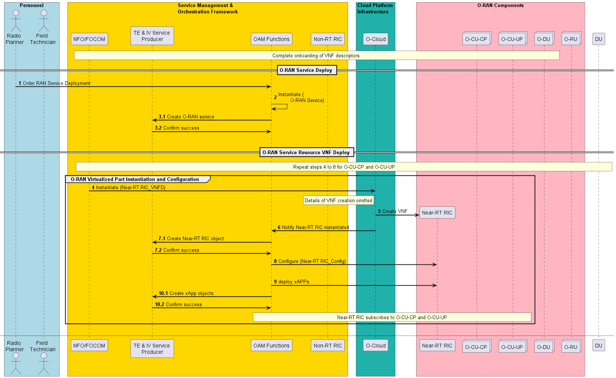

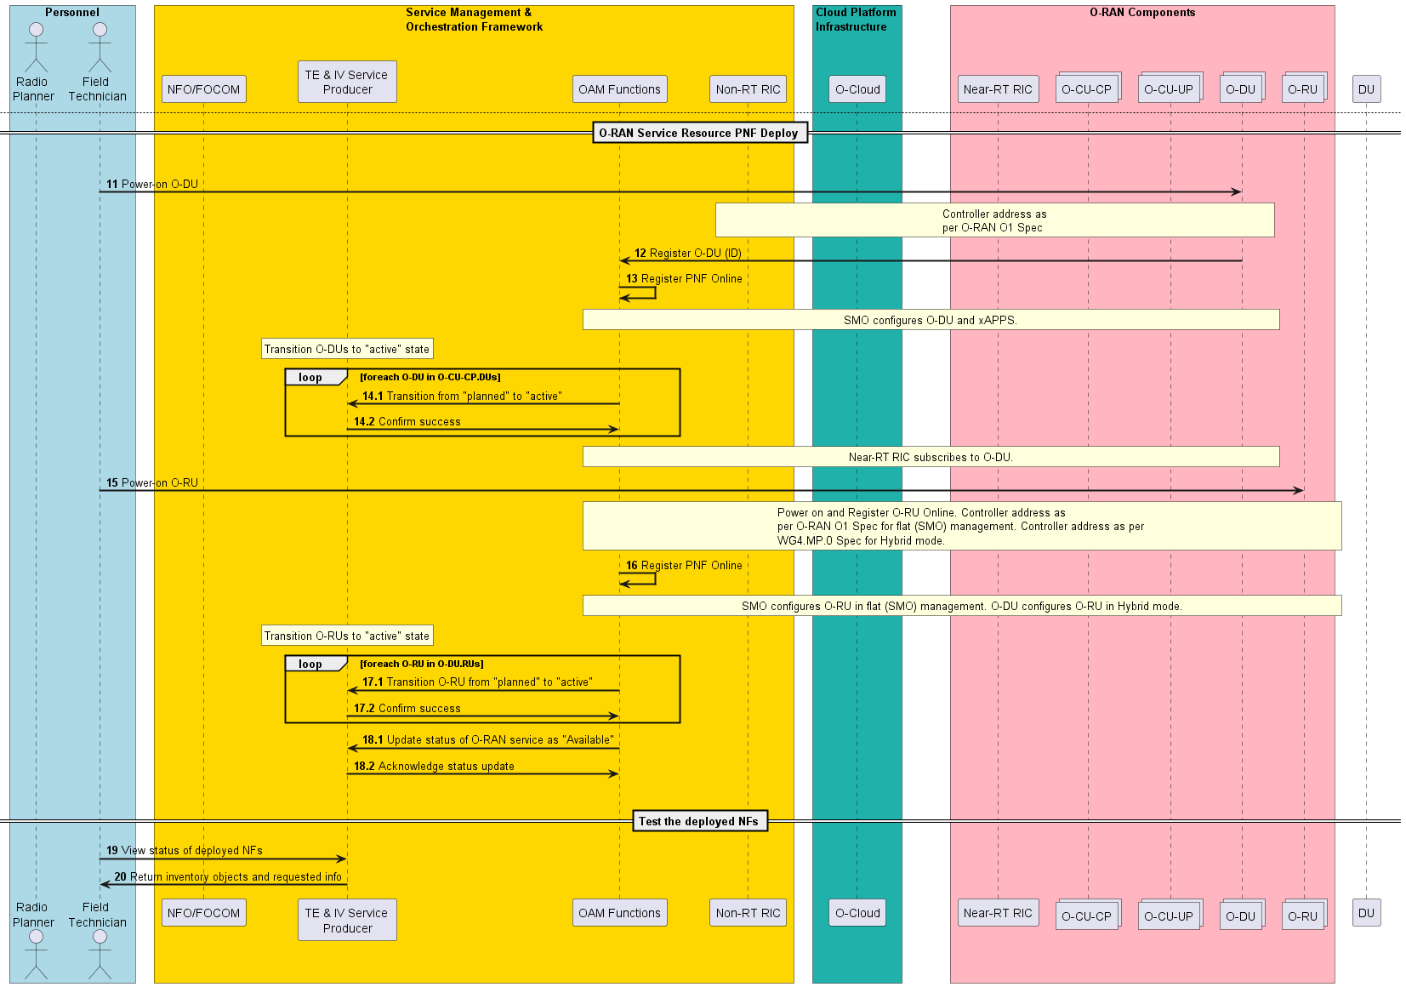

Figure 4.1.1.3-1: O-RAN network provisioning

### 4.1.1.4 Required Data

* A unique identifier is assigned during creation of TE&IV resource in the inventory, which is returned by the TE&IV   
   service producer in the response for create operation.
* Representation of TE&IV resources in the inventory may include, but not limited to the following:
  + Unique identifier, name, lifecycle state of the resource etc.
* Any of the above parameters may be used to update or query the TE&IV resources

## 4.1.2 Use case 2: Alarm query with TE&IV services

This use case is improvement of alarm query use case specified in R1UCR [i.6] with TE&IV services.

This use case allows an rApp acting as service consumer to query identities of cells and NF Deployments in specific geo-location and then use retrieved identities to query alarm information.

### 4.1.2.1 Background and goal of the use case

An rApp acting as service consumer can query from the RAN OAM-related functions information about an individual alarm, a set of alarms matching provided filtering criteria or all active alarms available in the alarm list.

An rApp acting as TE&IV service consumer can query TE&IV service provider to get identities of cells and NF Deployments in specific geo-location.

### 4.1.2.2 Entities/resources involved in the use case

1. RAN OAM-related functions
   1. Receives request to query alarm information,
   2. Responds with success or failure to the query of alarm information
2. rApp
   1. Initiates query of alarm information
   2. Inititaes query to get identities of cells and NF Deployment in specific geo-location.
3. TE&IV service producer
   1. Exposes TE&IV services based on a Topology and Inventory Models and APIs, which offers among others the capability to provide the relationship between TE&IV resources and geo-location
   2. Consumes the data provided by the SMO functions (e.g., O1-related data, O2-related data, DME, SME, etc) and exposes it via the Topology and Inventory Model and APIs.

### 4.1.2.3 Solutions

Table 4.1.2.3-1: Query alarm information use case using TE&IV services

|  |  |  |
| --- | --- | --- |
| Use Case Stage | Evolution / Specification | <<Uses>>  Related use case |
| Goal | Query of alarm information of cells in a specific geo-location from RAN OAM-related functions using data from TE&IV services |  |
| Actors and Roles | * rApp in the role of service consumer that queries alarm information. * RAN OAM-related functions provides alarm information in response to the alarm queries. * TE&IV service producer |  |
| Assumptions | n/a |  |
| Preconditions | The rApp is deployed and authorized to query RAN OAM-related functions and TE&IV service producer. Geo-location of cell and NF Deployment is available for query in the TE&IV service producer |  |
| Begins when | The rApp determines the need to query alarm information from cells in specific geo-location |  |
| Step 1 (M) | The rApp queries the TE&IV service producer for identies of cells and its associated NF deployments in specific geo-location |  |
| Step 2 (M) | TE&IV service producer validates the request and retrieves cells and its associated NF deployments in specific geo-location from the TE&IV repositories. |  |
| Step 3 (M) | TE&IV service producer returns the identities of cells and its associated NF Deployment instances. |  |
| Step 4 (M) | The rApp queries alarm information from the RAN OAM-related functions by providing the rAppId, NF Deployment/Cells and optional query information that determines the requested result set. |  |
| Step 5 (M) | The RAN OAM-related functions validate the query information. |  |
| Step 6 (M) | The Ran OAM-related functions respond to the rApp with success along with the requested alarm information. |  |
| Ends when | The rApp has successfully queried the alarm information |  |
| Exceptions | n/a |  |
| Post Conditions | n/a |  |
| Traceability | REQ-TE&IV-MODEL-FUN6 |  |

@startuml  
!pragma teoz true  
skinparam ParticipantPadding 70  
skinparam BoxPadding 10  
skinparam defaultFontSize 12  
skinparam lifelineStrategy solid  
  
  
box "Non-RT RIC" #whitesmoke  
 participant "rApp" as rapp  
endbox  
  
box "Non-anchored functions in SMO/Non-RT RIC Framework" #cadetBlue  
 participant "RAN OAM-related functions" as fmsp  
 participant “TE&IV service producer” as Tproducer  
endbox  
  
rapp -> Tproducer : Query for cells and NF Deployments in specific geo-location  
Tproducer --> Tproducer : validate the request and \n retrieve cell and its associated NF deployments in specific geo-location\n from the TE&IV repositories.  
Tproducer -> rapp : Return cell and its associated NF Deployments  
rapp -> fmsp: <<R1>> Query alarm information request (rAppId, NF Deployment,queryInfo)  
fmsp --> fmsp: AuthZ  
note right  
Check authorization in collaboration  
with SME functions  
end note  
fmsp --> fmsp: Validate request  
fmsp -> rapp: <<R1>> Query alarm information response (alarmInfo)  
@enduml

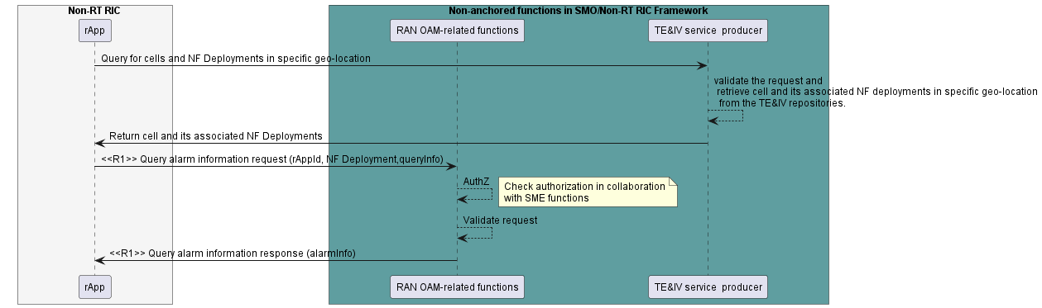

Figure 4.1.2.3-1: Query alarm information use case flow diagram

### 4.1.2.4 Required data

TE&IV service producer has the relationship information about the cells and NF deployments associated with geo-location.

The query request to TE&IV service producer contains the geo-location [1], cell type and NF Deployment type. TE&IV service returns identities of the requested cell and its associated NF deployment in the requested geo-location.

The Query alarm information request contains the rAppId and optional query information. The query information determines the requested alarm information, for instance a single alarm with a particular alarm ID, all alarms in the alarm list or a subset of these alarms that match a set of filtering parameters.

The Query alarm information response contains the requested alarm information scoped by the query information provided in the request.

## 4.2 New Topology and Inventory Use Cases

## 4.2.1 Use case 1: Topology based alarm correlation

This use case provides the background , motivation , and requirements for Topology based alarm correlation , allowing operators to resolve or handle the alarms triggered through O1, O2 and M-Plane interface(in case of hybrid O-RU) using Topology Exposure and Inventory Management services, thereby reducing effort for root cause analysis of alarms.

### 4.2.1.1 Background and goal of the use case

Faults are inevitable in big distributed system like O-RAN. Unhandled alarms will degrade the performance of the O-RAN network and will impact the users. It is important to quickly find the relationship between different alarms. Faults in O1 nodes are reported through O1 interface, faults in O-Cloud resources are reported through O2 interface and faults in the O-RU are reported through M-Plane interface. With disaggregated nature of O-RAN architecture, it becomes difficult to determine the relationship between alarms raised in O1 node or O-Cloud or O-RU. Topology and Inventory models with capability to show relationship between RAN resources , O-Cloud resources and transport resources is required to pinpoint the relationship between alarming resources.  
   
 Scenario: Internal network switch failure in O-Cloud may impact NF Deployments which might affect the O-RAN network. Different alarms will be raised over O2, O1 and M-Plane interface as result of cascading effect of failure of an internal network switch in O-Cloud.

Topology based alarm correlation shall query the TE&IV service producer to understand the relationships between the topology/inventory resources and the alarmed resources.

The objective of this use case is to leverage TE&IV services for alarm correlation in order to determine the root cause of a problem

### 4.2.1.2 Entities/resource involved in the use case

1. TE&IV service consumer (e.g., : an rAPP)
2. Queries TE&IV service producer to get the relationship between alarmed resources
3. TE&IV service producer
4. Exposes TE&IV services based on Topology and Inventory Models and APIs, which offers among others the capability to provide the relationship between resources provided by O1 nodes, O-Cloud and O-RU
5. Consumes the data provided by the SMO functions (e.g., O1-related data, O2-related data, DME, SME, etc) and exposes it via the Topology and Inventory Models and APIs

### 4.2.1.3 Solutions

**Table 4.2.1.3-1 Topology based Alarm Correlation**

|  |  |  |
| --- | --- | --- |
| **Use Case Stage** | **Evolution / Specification** | **<<Use>>  Related Use** |
| Goal | Alarm correlation using TE&IV services |  |
| Actors and Roles | TE&IV service consumer (e.g., an rApp) TE&IV service producer |  |
| Assumptions | All relevant functions and components are instantiated. TE&IV services are supported and active in the SMO. |  |
| Pre Conditions | Network is operational. TE&IV service producer has an up-to-date view of the O-RAN network including RAN resources, NF Deployments, O-Cloud resources and transport resources |  |
| Begins when | Fault occurs in O-RU, O-DU and O-Cloud Several alarms are received by TE&IV service consumer |  |
| Step 1 (M) | TE&IV service consumer queries the TE&IV service producer to get the NF Deployment instances using those O-Cloud resources that were indicated in the O-Cloud alarm resources |  |
| Step 2 (M) | TE&IV service producer retrieves this data from the TE&IV repositories. |  |
| Step 3 (M) | TE&IV service producer returns the data on the NF Deployment instances using the faulty O-Cloud resources to the TE&IV service consumer. |  |
| Step 4 (M) | TE&IV service consumer queries the TE&IV service producer about the NF Deployment instances of those NF that were impacted by the alarms on the NF |  |
| Step 5 (M) | TE&IV service producer retrieves from the TE&IV repositories the data about the existing NF Deployment instances associated with the impacted NF. |  |
| Step 6 (M) | TE&IV service producer returns to the TE&IV service consumer the list of NF Deployment instances selected in the previous step. |  |
| Step 7 (M) | TE&IV service consumer queries the TE&IV service producer to get the cells associated with impacted NF Deployment instances and connected O-RUs impacted by the M-Plane alarm. |  |
| Step 8 (M) | TE&IV service producer retrieves from the TE&IV repositories the data about O-RUs connected to the impacted NF Deployment instances and also retrieves data about the /cells associated with NF Deployment instances and M-Plane alarm. |  |
| Step 9 (M) | TE&IV service producer returns to the TE&IV service consumer the list of impacted O-RUs and cells. |  |
| Ends when | TE&IV service producer provided to the TE&IV service consumer all the requested data that correlated the faulty O-Cloud resources with the NF Deployment instances and ultimately with the cells that were using those O-Cloud resources. |  |
| Exceptions | None Identified |  |
| Post Conditions | TE&IV service consumer obtained the needed correlation data between the faulty O-Cloud resources, the O-RAN NFs and the cells impacted. |  |
| Traceability | REQ-TE&IV-MODEL-FUN1 , REQ-TE&IV-MODEL-FUN2 , REQ-TE&IV-MODEL-FUN3 , REQ-TE&IV-MODEL-FUN4 , REQ-TE&IV-MODEL-FUN5 ,REQ-TE&IV-MODEL-FUN7, REQ-TE&IV-MODEL-FUN8, REQ-TE&IV-MODEL-FUN9, REQ-TE&IV -CRUDQ-FUN3 |  |

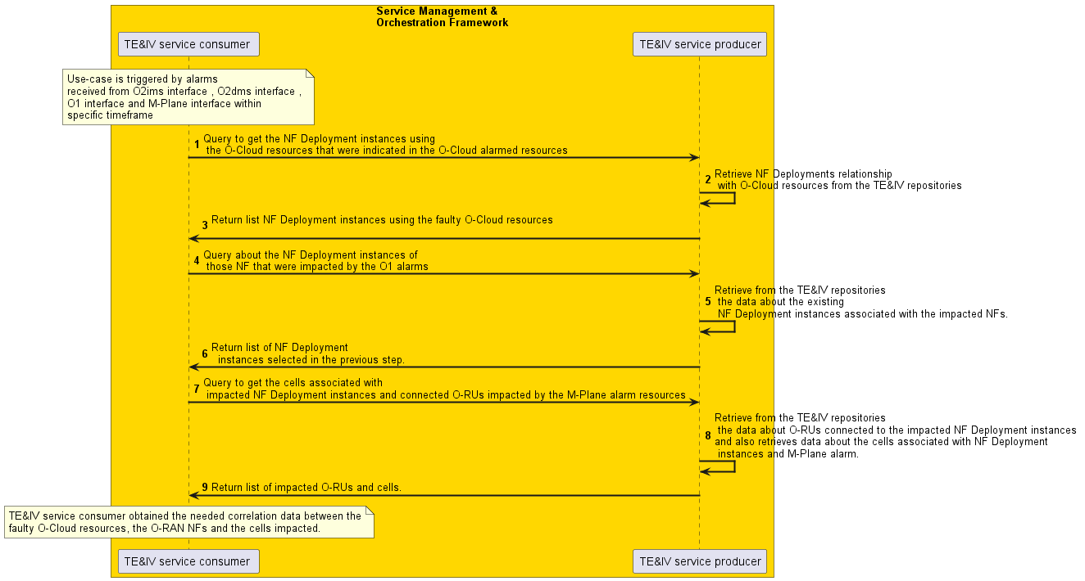

Figure 4.2.1.3-1: Topology based Alarm Correlation

### 4.2.1.4 Required data

TE&IV service producer has the information about the O-Cloud resources, the O-RAN NFs and their associated NF Deployments.

TE&IV service producer has information regarding the relationship between O-Cloud resources, the O-RAN NFs and their associated NF Deployments.

TE&IV service producer has the connectivity relationships information  
- Between the O-RAN NFs  
- Between the O-Cloud resources

TE&IV service producer has the logical resource relationship of RAN resources.

TE&IV service producer has the identity information of TE&IV resources which enables correlation of the different identities used across different functions in SMO.

TE&IV service producer shall provide fault state and associated properties of the TE&IV resources to reflect the result of alarm correlation

## 4.2.2 Use case 2: O-RAN Network Planning

### 4.2.2.1 Background and goal of the use case

Network Planning enables CSPs to design, manage and optimize networks efficiently. Network planning and network design aim at ensuring that the new telecommunications network operates at optimum cost and has sufficient capacity and reliability to meet the needs of the subscriber and operator. With the advent of cloud native technologies and the ability to iterate and deploy quickly through containers, microservices etc., the time period between network planning and design to network deployment and realization has reduced significantly compared to the traditional process.

Inventory supports the network planning process by storing and providing information regarding planned networks. TE &IV services enable bulk upload of network data to inventory, which eases planning and deployment of large scale networks

The objective of this use case is to illustrate the use of bulk upload services offered by TE&IV service producer during O-RAN network planning and deployment.

NOTE: File format for bulk upload of inventory data is dependant on the common topology and inventory model and is not covered in this specification

### 4.2.2.2 Entities/resource involved in the use case

1. Service Management and Orchestration Framework - Supports the deployment of PNFs
2. OAM Functions -. Manages provisioning of NFs and state of inventory objects
3. NFO - Interacts with O-Cloud to perform life cycle management of NFs
4. TE&IV service producer - Enables bulk upload of data in the inventory
5. O-Cloud - Interacts with SMO for deployment of NFs

### 4.2.2.3 Solutions

Table 4.2.2.3-1: O-RAN Network Planning

| **Use Case Stage** | **Evolution / Specification** | **<<Uses>>**  **Related use** |
| --- | --- | --- |
| Goal | Illustrate the role of TE & IV services in O-RAN network planning and deployment |  |
| Actors and Roles | 1. Service Management and Orchestration Framework: TE & IV service producer, OAM Functions 2. Radio and Transport network designers 3. Radio and Transport network planners 4. Field Technician 5. Network Operator |  |
| Assumptions | The Service Management and Orchestration Framework and O-Cloud are connected and interact normally |  |
| Pre-conditions | * Planning data for RAN, transport networks etc. are available in files in pre-defined format * Planning data has information about NF hierarchy, geo-location, O-Cloud Id for NF deployment etc. * O-DU and O-RU are PNFs * PNFs are constructed/installed * Transport network is installed * O-Cloud supports platform and resource management normally * NF Software Package has been uploaded to the O-Cloud * O1 interface is configured between NFs and the SMO |  |
| Begins when | Radio and Transport network planners decide to create planned network in a specific geo-location based on finalized design from network designers |  |
| Step 1 (M) | Radio planner uses TE&IV services to upload RAN planning data |  |
| Step 2 (M) | TE&IV service producer creates RAN objects and associations in the planned inventory as per uploaded data |  |
| Step 3 (M) | TE&IV service producer notifies the successful creation of RAN objects to radio planner |  |
| Step 4 (M) | Transport network planner leverages TE&IV services to upload transport planning data  NOTE: Only those transport parameters required to configure O-RAN end points constitute transport planning data. |  |
| Step 5 (M) | TE&IV service producer creates transport objects in the planned inventory as per uploaded data |  |
| Step 6 (M) | TE&IV service producer notifies the successful creation of transport objects to transport planner |  |
| Step 7 (M) | The SMO queries O-Cloud (based on the O-Cloud Id in planning data) for available O-Cloud capacity to deploy NFs (O-CU-CP, O-CU-UP) |  |
| Step 8 (M) | O-Cloud provides the requested information. |  |
| Step 9 (M) | The SMO interacts with O-Cloud for deployment of O-CU-CP and O-CU-UP NFs as per section 2.2.1, O-RAN Service Provisioning use case in [i.2] |  |
| Step 10 (M) | The deployed NFs in O-Cloud notify the SMO about successful instantiation |  |
| Step 11(M) | The SMO uses TE&IV services to transition the state of NF inventory objects to "active" |  |
| Step 12 (M) | Field technician powers on the PNFs (O-DUs and O-RUs). |  |
| Step 13 (M) | The PNFs send registration to the SMO |  |
| Step 14.1 (M) | The SMO triggers provisioning of NFs using planned configuration data ; The SMO configures the NFs as per section 2.2.1, O-RAN Service Provisioning use case in [i.2] |  |
| Step 14.2 (M) | The SMO triggers provisioning of PNFs as per section 2.2.1, O-RAN Service Provisioning use case in [i.2] |  |
| Step 15 (M) | The SMO uses TE&IV services to transition the state of PNF inventory objects to "active" |  |
| Ends when | The SMO holds up-to-date, active inventory of O-RAN NFs. |  |
| Exceptions | None |  |
| Post Condition | O-RAN network has been established and provides service to customers |  |
| Traceability | REQ -TE&IV-CRUDQ-FUN1 |  |

@startuml

skinparam sequenceArrowThickness 2

skinparam ParticipantPadding 5

skinparam BoxPadding 10

autonumber

Box “Personnel” #lightblue

Actor “Radio \nPlanner” as RP

Actor "Transport \nPlanner" as TP

Actor “Field \nTechnician” as Tech

Actor "Network \nOperator" as NO

End box

box “Service Management & \nOrchestration Framework” #gold

Participant “TE&IV \nService Producer” as IVF

Participant “OAM Functions” as SMO

Participant "NFO" as NFO

end box

box "O-RAN Components"#lightpink

collections “NFs/PNFs” as NFs

end box

box “O-Cloud Platform \nInfrastructure” #lightseagreen

participant “O-Cloud” as IMF

end box

== Create Radio network objects in planned inventory ==

RP-> IVF: Prepare and upload RAN Planning data

IVF -> IVF: Create RAN objects in planned inventory

IVF -> RP: Notify creation of RAN objects

Rnote over SMO, IVF

Notify subscriber(s) about creation of RAN objects

End rnote

== Create Transport network objects in planned inventory ==

TP->IVF: Prepare and upload transport planning data

IVF -> IVF: Create transport objects in planned inventory

IVF -> TP: Notify creation of transport objects

Rnote over SMO, IVF

Notify subscriber(s) about creation of transport objects

End rnote

==Deploy NFs and PNFs==

NFO->IMF: Query available capacity of OCloud

IMF->NFO: Return requested information

Rnote over SMO, IMF

Details of NF instantiation omitted

End rnote

NFO->IMF: Deploy NFs

IMF->SMO: Notify successful instantiation of NFs

Rnote over SMO, NFs

Initiate network discovery for NFs through O-Cloud to query NF state (details are omitted).

End rnote

SMO->IVF: Transition NF inventory objects to "active"

Rnote over SMO, NFs

Details of PNF deployment omitted

End rnote

Tech->NFs: Power-on PNFs

NFs->SMO: Register PNFs Online

== Configure NFs ==

Rnote over SMO, NFs

Details of NF configuration omitted

End rnote

Autonumber 14.1

SMO->IMF: Configure NFs

SMO->NFs: Configure PNFs

Autonumber 15

SMO->IVF: Transition PNF inventory objects to "active" state

==Monitor health of newly deployed NFs ==

Rnote over NO, NFs

NFs report alarms and performance metrics to SMO. Network Operator monitors fault and performance of NFs.

End rnote

@enduml

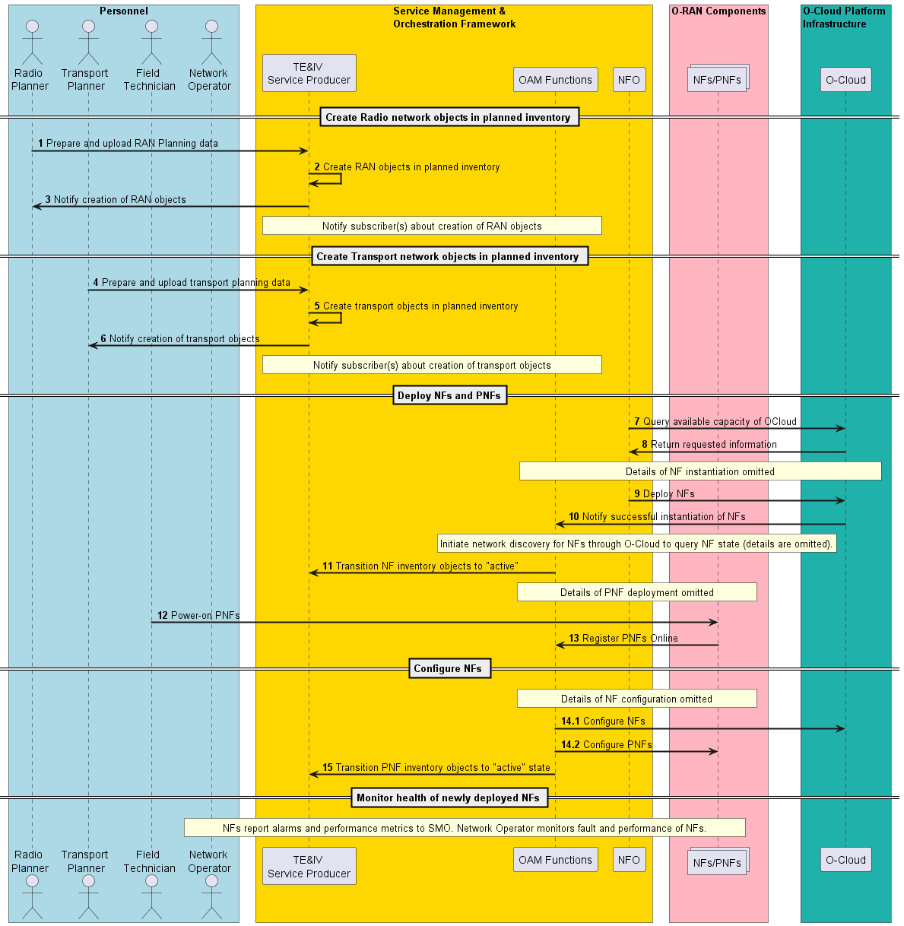

Figure 4.2.2.3-1: O-RAN Network Planning

### 4.2.2.4 Required Data

Geo-location Id and O-Cloud Id may be used for deployment of PNFs and NFs.

A unique identifier is assigned during create operation of TE&IV resource, which is returned by the TE&IV service producer in the response for create operation.

Representation of TE&IV resources in the inventory may include, but not limited to the following:

* Unique identifier, name, lifecycle state of the resource etc.

# 5. Requirements

## 5.1 Functional Requirements

**Table 5.1-1: TE&IV services Functional Requirements**

|  |  |  |
| --- | --- | --- |
| **REQ** | **Description** | **Notes** |
| REQ -TE&IV-CRUDQ-FUN1 | TE&IV services shall support the creation of TE&IV resources in repositories. | Use case 4.1.1 |
| REQ- TE&IV -CRUDQ-FUN2 | TE&IV services shall support the update of TE&IV resources in repositories. | Use case 4.1.1 |
| REQ-TE&IV -CRUDQ-FUN3 | TE&IV services shall support the query of TE&IV resources in repositories. | Use case 4.1.1 Use case 4.1.2 Use case 4.2.1 |
| REQ-TE&IV-MODEL-FUN1 | TE&IV services shall have the capability to provide data about RAN resources and the relationship between them. | Use case 4.2.1 |
| REQ-TE&IV-MODEL-FUN2 | TE&IV services shall have the capability to provide data about NF Deployments and the relationships between them. | Use case 4.2.1 |
| REQ-TE&IV-MODEL-FUN3 | TE&IV services shall have the capability to provide data about O-Cloud resources available in the network and the relationships between them. | Use case 4.2.1 |
| REQ-TE&IV-MODEL-FUN4 | TE&IV services shall have the capability to provide data on the relationships between the RAN resources, NF Deployment instances and O-Cloud resources. | Use case 4.2.1 |
| REQ-TE&IV-MODEL-FUN5 | TE&IV services shall be capable of uniquely identifying different types of TE&IV resources. | Use case 4.2.1 Use case 4.1.1 Use case 4.2.2 |
| REQ-TE&IV-MODEL-FUN6 | TE&IV services shall have the capability to support geo-location [1] based query. | Use case 4.1.2 |
| REQ-TE&IV-MODEL-FUN7 | TE&IV services shall have the capability to provide data on the connectivity relationships between the TE&IV resources. | Use case 4.2.1 Use case 4.1.1 |
| REQ-TE&IV-MODEL-FUN8 | TE&IV services shall have the capability to provide data on the lifecyle state of the TE&IV resources. | Use case 4.2.1 Use case 4.2.2 |
| REQ-TE&IV-MODEL-FUN9 | TE&IV services shall have the capability to provide data on the state of TE&IV resources derived from configuration, fault and performance data. | Use case 4.2.1 |

## 5.2 Non-Functional Requirements

Void

# Change History

|  |  |  |
| --- | --- | --- |
| Date | Revision | Description |
| 2023.03.09 | 01.00 | Incorporate approved CRs : ERI-2022.09.22-WG10-ERI-021-Terminology-v03 , NEC-2022-09-10-.WG10-CR-0001-Inventory_ORAN_provisioning_usecase_v06, NEC-2022-12-08-.WG10-CR-0002-Inventory_ORAN_Network_Planning_usecase_v08, NEC-2023-01-26-.WG10-CR-0003-Inventory_Functional_Requirements_v02 ,NEC-2023-02-09-.WG10-CR-0003-ORAN_TAI_Scope_v01, NEC-2023-02-23-.WG10-CR-0005-ORAN_Inventory_EN_Resolution_v03 , NEC-2023-02-28-.WG10-CR-0006-ORAN_Inventory_EN_Resolution_2_v02, ERI-2023.03.03-WG10-ERI-029-Functional-Requirement-v03, ERI-2023.01.27-WG10-CR-027-use-case-Topology-based-alarm-correlation-v04, ERI-2023.02.15-WG10-CR-028-use-case-R1 Alarm query using TE&IV Services-v04 |
| 2023.03.13 | 01.00 | Address comments from WG10 review |